Project Design Phase-II
Data Flow Diagram & User Stories
Date | 03 october 2026
Team ID | SWTID-2026-4339
Project Name | Streamlining IT Procurement: Automating Standard Laptop Orders with Flow Designer
Maximum Marks | 4 Marks
Data Flow Diagrams:
A Data Flow Diagram (DFD) is a traditional visual representation of the information flows within a system. A neat and clear DFD can depict the right amount of the system requirement graphically. It shows how data enters and leaves the system, what changes the information, and where data is stored.
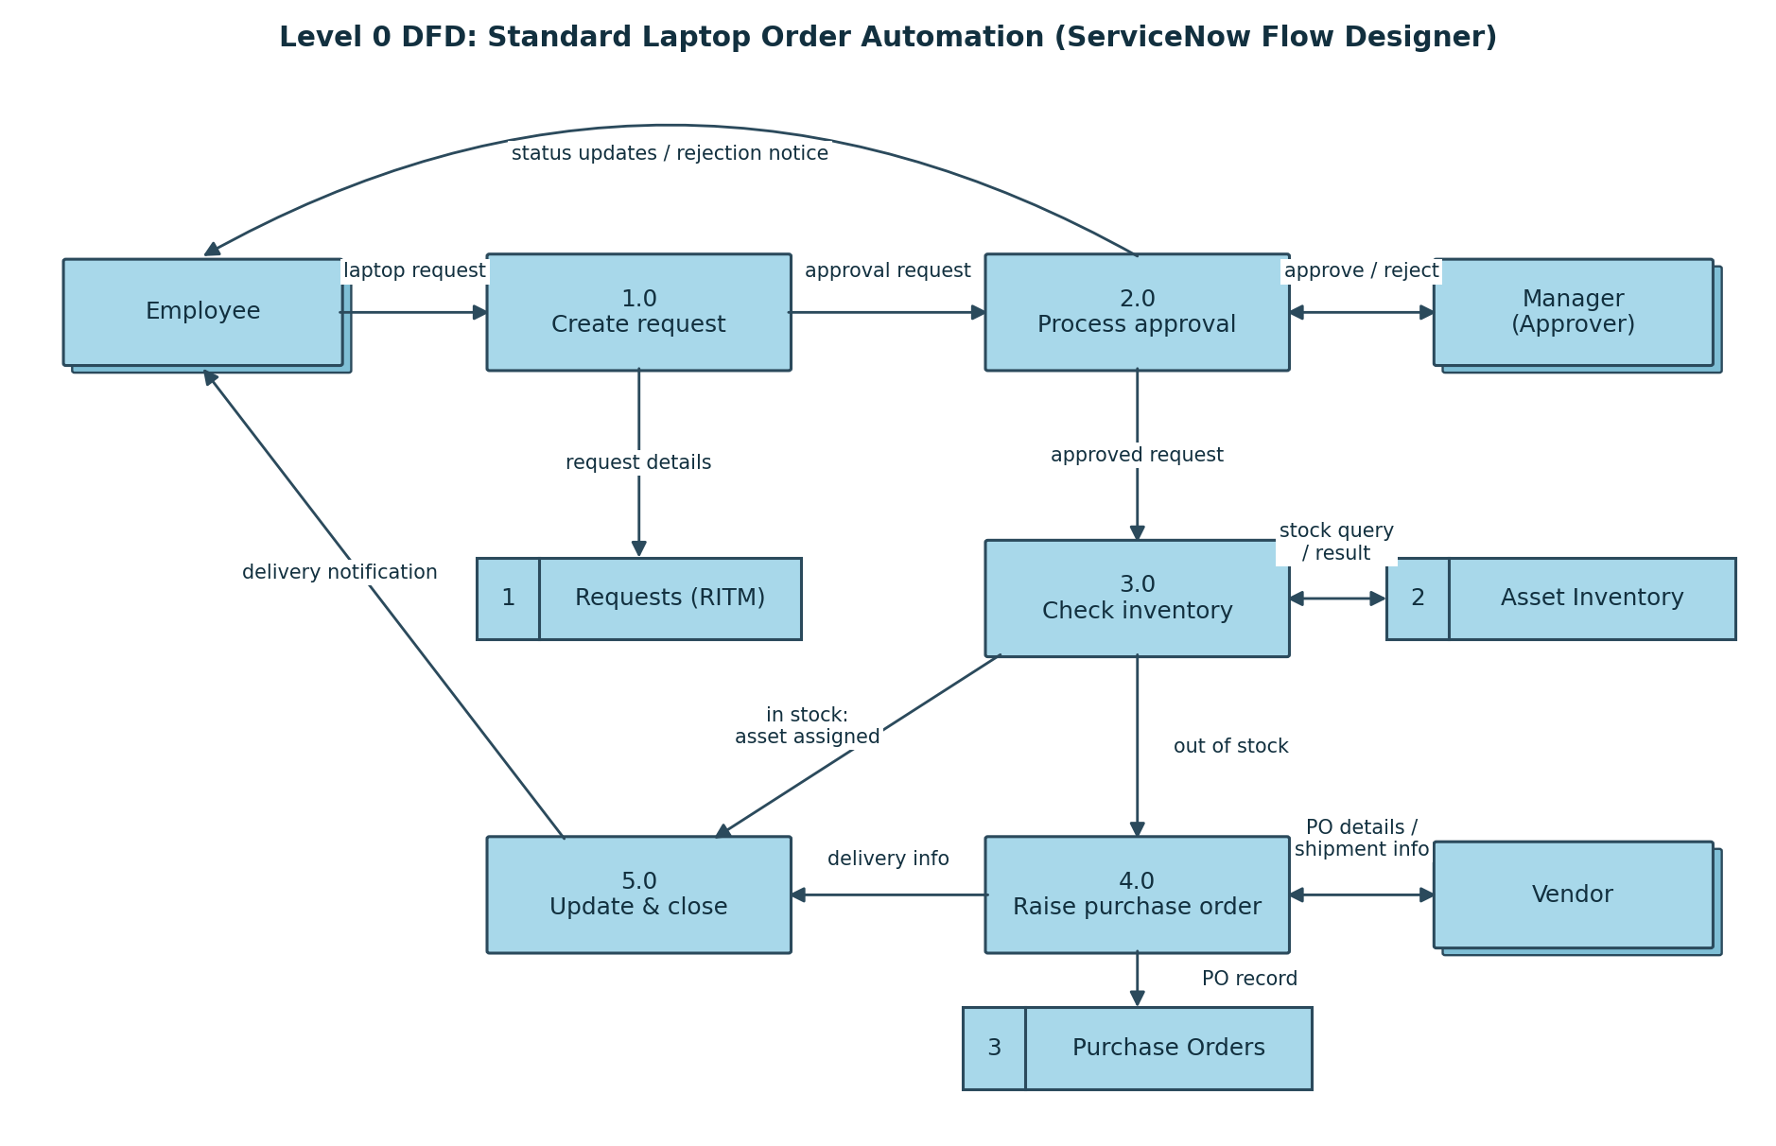
User Stories
Use the below template to list all the user stories for the product.
User Type | Functional Requirement (Epic) | User Story Number | User Story / Task | Acceptance criteria | Priority | Release
Employee | Request Submission | USN-1 | As an employee, I can select Standard Laptop from the Service Catalog and submit the request. | A request (RITM) is created and stored. | High | Sprint-1
 |  | USN-2 | As an employee, I will receive a confirmation email after submitting the request. | Email arrives with the RITM number. | High | Sprint-1
 | Request Tracking | USN-3 | As an employee, I can track the status of my request in the portal. | Current status is visible until the request is closed. | Medium | Sprint-2
 |  | USN-4 | As an employee, I will be notified when my laptop is delivered. | Delivery notification email is received. | Medium | Sprint-2
Manager (Approver) | Approval | USN-5 | As a manager, I receive an approval request and can approve or reject it. | Flow continues or closes based on my decision. | High | Sprint-1
 |  | USN-6 | As a manager, I get a reminder if I have not responded in time. | Reminder is sent after the SLA time passes. | Medium | Sprint-2
IT Procurement Team | Fulfillment | USN-7 | As a procurement team member, I want stock checked automatically and the asset assigned to the user. | Asset in stock is linked to the employee. | High | Sprint-2
 |  | USN-8 | As a procurement team member, I get a purchase order task only when stock is unavailable. | PO task is auto-created for out-of-stock requests. | High | Sprint-2
Administrator | Configuration | USN-9 | As an administrator, I can configure the approval threshold and flow without code. | Changes apply to new requests. | Low | Sprint-3
 | Monitoring | USN-10 | As an administrator, I can see failed or delayed flow executions. | Errors are logged in flow execution history. | Low | Sprint-3

